Name: ____________________________________________

Date Completed: ___________________________________

AGSC 1352 – WELDING
SCORECARD

ELECTRIC ARC WELDING

PIPE FILLET WELD
#10

MATERIALS:
- 1 piece of ¼”x 3”x 3” plate steel
- 1 piece of 1-1/2” diameter x 2” black pipe
- E6011 & or E7018 electrodes

PROCEDURE:
- Cut plate steel & pipe according to specification.
- Place pipe in center of base metal
- Use E6011 electrode for a stringer pass
- Use E7018 electrode for a cover pass
- Check for leaks by pouring water into pipe and let stand
- DO NOT TURN IN HOT METAL

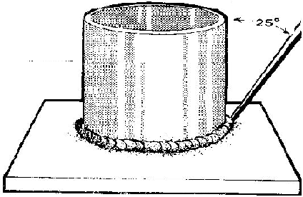

PIPE FILLET WELD
Scorecard

Follow direction: 4 pts ________________

Bead width 5 pts _________________

Uniformity of bead 5 pts _________________

Bead appearance 10 pts _________________

Techniques used 5 pts ________________

Penetration 7 pts ________________

Water holding capabilities 10 pts ________________

Safety 3 pts ________________

Total 50 pts ________________

Texas A&M University-Kingsville – Ag Mechanics Dept
Name: ____________________________________________

Date Completed: ___________________________________

AGSC 1451
SCORECARD

Oxy-Acetylene Cutting

MATERIALS:
- 1 piece – ¼” x 5” steel plate

PROCEDURE:
- Cut steel bar according to specification, illustrated below.
- Measure & mark layout
- Use a try square & soapstone to square end.
- Use proper procedures in setup & operating OA cutting equipment.
- Clean tip orifices.
- Use chart to determine pressures for cutting operation.
- Cut marked area.
- Cut according to specifications.
DO NOT TURN IN HOT

5”

1-1/2”

OXY-ACETYLENE CUTTING SKILL
Scorecard

Follow direction: 3 pts _________________

Measurements 20pts __________________

Uniform cuts 10 pts __________________

Visible slag 5 pts _________________

Evidence of beveling 10 pts ________________

Safety 2 pts ________________

Total 50 pts ________________

Texas A&M University-Kingsville – Ag Mechanics Dept

